|  |
| --- |
| EPAM Systems, RD Dep. |
| MTN.BI.07 Oracle Database Architecture |

|  |  |  |  |  |  |
| --- | --- | --- | --- | --- | --- |
| REVISION HISTORY | | | | | |
| Ver. | Description of Change | Author | Date | Approved | |
| Name | Effective Date |
| 1.0 | Initial status | Arina Marchenko | 01-11-2017 |  |  |

Contents

DATAFILES 3

BACKGROUND PROCESS SMON 5

# DATAFILES

Overview of Datafiles

A tablespace in an Oracle database consists of one or more physical datafiles. A datafile can be associated with only one tablespace and only one database.

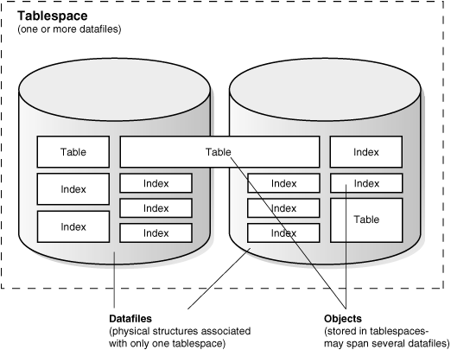

Oracle creates a datafile for a tablespace by allocating the specified amount of disk space plus the overhead required for the file header. When a datafile is created, the operating system under which Oracle runs is responsible for clearing old information and authorizations from a file before allocating it to Oracle. If the file is large, this process can take a significant amount of time. The first tablespace in any database is always the SYSTEM tablespace, so Oracle automatically allocates the first datafiles of any database for the SYSTEM tablespace during database creation.

Datafile Contents

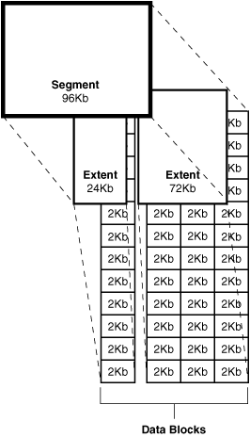

When a datafile is first created, the allocated disk space is formatted but does not contain any user data. However, Oracle reserves the space to hold the data for future segments of the associated tablespace—it is used exclusively by Oracle. As the data grows in a tablespace, Oracle uses the free space in the associated datafiles to allocate extents for the segment.

The data associated with schema objects in a tablespace is physically stored in one or more of the datafiles that constitute the tablespace. Note that a schema object does not correspond to a specific datafile; rather, a datafile is a repository for the data of any schema object within a specific tablespace. Oracle allocates space for the data associated with a schema object in one or more datafiles of a tablespace. Therefore, a schema object can span one or more datafiles. Unless table striping is used (where data is spread across more than one disk), the database administrator and end users cannot control which datafile stores a schema object.

Size of Datafiles

You can alter the size of a datafile after its creation or you can specify that a datafile should dynamically grow as schema objects in the tablespace grow. This functionality enables you to have fewer datafiles for each tablespace and can simplify administration of datafiles.

Note:

You need sufficient space on the operating system for expansion.

Offline Datafiles

You can take tablespaces offline or bring them online at any time, except for the SYSTEM tablespace. All of the datafiles of a tablespace are taken offline or brought online as a unit when you take the tablespace offline or bring it online, respectively.

You can take individual datafiles offline. However, this is usually done only during some database recovery procedures.

Temporary Datafiles

Locally managed temporary tablespaces have temporary datafiles ([tempfile](https://docs.oracle.com/cd/B19306_01/server.102/b14220/glossary.htm#i998188)s), which are similar to ordinary datafiles, with the following exceptions:

* Tempfiles are always set to NOLOGGING mode.
* You cannot make a tempfile read only.
* You cannot create a tempfile with the ALTER DATABASE statement.
* Media recovery does not recognize tempfiles:
  + BACKUP CONTROLFILE does not generate any information for tempfiles.
  + CREATE CONTROLFILE cannot specify any information about tempfiles.
* When you create or resize tempfiles, they are not always guaranteed allocation of disk space for the file size specified. On certain file systems (for example, UNIX) disk blocks are allocated not at file creation or resizing, but before the blocks are accessed.

Caution:

This enables fast tempfile creation and resizing; however, the disk could run of space later when the tempfiles are accessed.

* Tempfile information is shown in the dictionary view DBA_TEMP_FILES and the dynamic performance view V$TEMPFILE, but not in DBA_DATA_FILES or the V$DATAFILE view.

# BACKGROUND PROCESS SMON

**System Monitor (SMON).** Maintains overall health and safety for an Oracle instance. SMON performs crash recovery when the instance is started after a failure and coordinates and performs recovery for a failed instance when you have more than one instance accessing the same database, as with Real Application Clusters. SMON also cleans up adjacent pieces of free space in the datafiles by merging them into one piece and gets rid of space used for sorting rows when that space is no longer needed.

The **system monitor process (SMON)** performs recovery, if necessary, at instance startup. SMON is also responsible for cleaning up temporary segments that are no longer in use and for coalescing contiguous free extents within dictionary managed tablespaces. If any terminated transactions were skipped during instance recovery because of file-read or offline errors, SMON recovers them when the tablespace or file is brought back online. SMON checks regularly to see whether it is needed. Other processes can call SMON if they detect a need for it.

With Real Application Clusters, the SMON process of one instance can perform instance recovery for a failed CPU or instance.